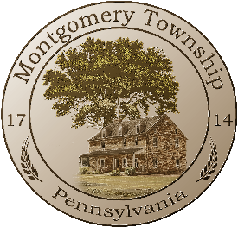
Montgomery Township
Environmental Advisory Committee
November 25, 2025
7:00PM
Township Administration Building
Agenda

Click here to join virtually via Microsoft Teams

REGULAR MEETING

- Call to Order

- Pledge of Allegiance

- Approval of Minutes – May 27, 2025

- New Business
  - Welcome New EAC Member – Paul
- Old Business
  - Updates – Naturalization Initiatives
- Other Business
- Public Comment for items not on agenda
- Adjournment - The EAC will meet next on January 27, 2026

